Block Diagram

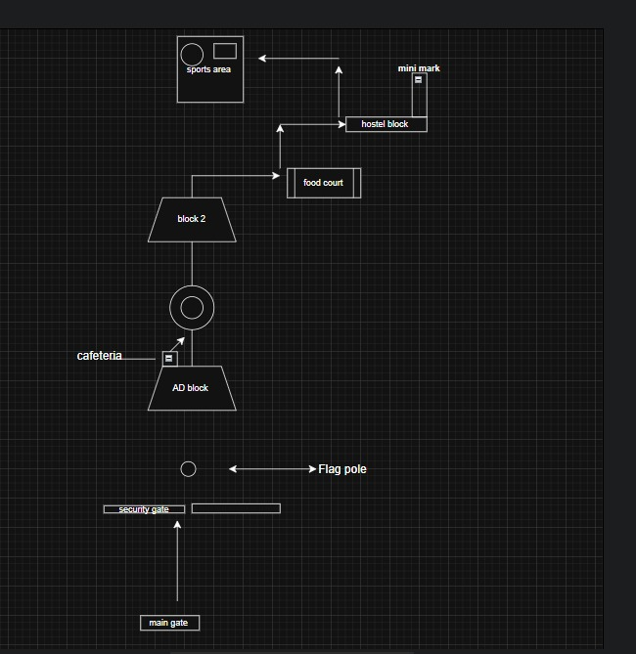

System Architecture Diagram
User
↓
Chatbot interface
↓
Bot Engine

Pathfinding Database
Module

Campus Graph

Output (Route

- MODULES
1. User Module
This part allows students or visitors to give their starting point and destination. It shows the route in simple step-by-step text, so users can easily follow directions inside the campus.
2. Navigation Module
This module calculates the path between locations using the campus map. It can find the shortest or easiest route and guide users toward places like the hostel, food court, or sports area.
3. Database Module
All details of the campus, such as building names, distances, and connections, are stored here. Whenever the bot needs information, it reads from this module.
4. Admin Module
The admin can update locations or routes in case of new blocks or changes in the campus. This ensures the map and routes stay correct.
DATABASE DESIGN
- Database Design (Simple Plan)
- Locations Table → Stores building ID, name, and description.
- Routes Table → Stores paths between two buildings with distances.
- Info Table → Stores extra details (like “Library open 9AM–

